**For Kids’ Sake!**

**Parenting Workshops for Moms & Dads**

Are you a parent who is going through or has gone through a separation or divorce?

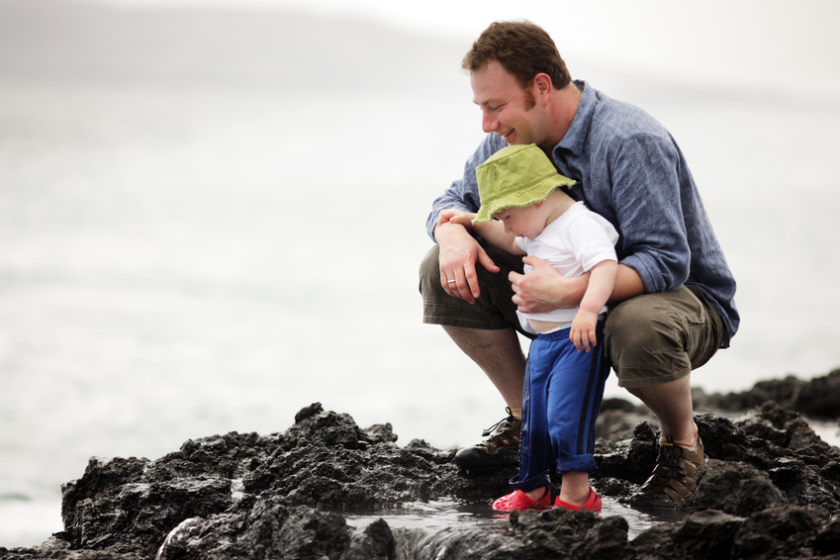

Register for one or more of our **free** workshops

**Location: #200-2540 Shaughnessy Street, Port Coquitlam, B.C.**

**www.tricitytransitions.com**

|  |  |
| --- | --- |
| **The Effects of Separation & Divorce on Children**  You will learn common child reactions to family break-up; how to recognize when your child may need help; how to recognize and understand your children’s feelings; and what is appropriate and not appropriate to share about the break-up with your children. | Tuesday February 22  9:30-11:30 a.m.  **-OR-**  Tuesday March 29  6:30-8:30 p.m. |
| **Supporting Your Child’s Feelings**  You will learn ways to support your child when they are sad, angry or worried; how to talk to a child about their feelings and yours; andwhat your child needs to feel safe and supported during and after a family break-up. | Tuesday March 1  9:30-11:30 a.m.  **-OR-**  Tuesday April 12  6:30-8:30 p.m. |
| **Effective Co-Parenting**  You will come to understand your co-parenting style; learn what you can do to be a cooperative parent; learn ways to keep calm when dealing with a difficult ex-partner; and learn skills for effective communication and conflict resolution. | Tuesday March 8  9:30-11:30 a.m. |
| **Single Parenting**  You will learn about the impact of separation and divorce on children; find out how to adjust to parenting independently; and gain skills such as how to discipline and communicate with your children more effectively, so that you can feel more comfortable in your new role as a single parent. | Tuesday March 15  9:30-11:30 a.m. |
| **I’m a Step Parent . . . Now What?**  You will learn how to improve your relationship with your step children and how to reduce conflict; how to support family changes and help your child adjust to a new parent; and discover your role as a step-parent in discipline, setting ground rules and more. | Tuesday March 22  9:30-11:30 a.m. |

**To register, please call 604-941-7111**

